Unit 1

Semester 1 2019

ATAR Chemistry Test 2

**Organic Chemistry Test**

**Name** ____________________________

**PART ONE: MULTIPLE CHOICE (10 Marks)**

**Answer all questions in Part 1 on the Multiple-Choice Answer Sheet provided, using a blue or black pen or HB pencil.**

1. Which of the following is an isomer of hexane?

a) 2‑methylbutane

b) 2,2‑dimethylbutane

c) 2‑methylpropane

d) 2‑ethylpropane

2. The general formula for an alkane would be

a) Cn-1H2n+2

b) CnH2n

c) Cn-1H2n-2

d) CnH2n+2

3. Which of the following compounds will not undergo an addition reaction with chlorine?

1. CH2=CH2
2. CH3CH=CH2
3. CH2=CHCl
4. CH3CH2CH3

4. Which one of the following hydrocarbons is least likely to react with hydrogen (H2)?

1. C5H10
2. C3H6
3. C2H4
4. C4H10

5. Which one of the following straight chain compounds is an **unsaturated hydrocarbon?**

a) C4H10

b) C6H12

c)C6H14

d) C2H5Cl

6. Bromine water (Br2) is rapidly decolourised when a little of it is added to

a) methane

b) ethene

c) ethane

d) benzene

7. The reaction of chlorine with methane liberates HCl gas. This reaction is called

a) addition

b) substitution

c) combustion

d) saturation

8. The bonds between carbon atoms in benzene are

a) single bonds

b) double bonds

c) alternating single and double bonds

d) intermediate between single and double bonds

9. Which of the following is **NOT TRUE** of alkanes:

a) Substitution reactions will occur in the presence of chlorine or bromine and UV light

b) High energy is needed to break the C-H bond

c) They undergo combustion to produce carbon dioxide and water

d) Alkanes cannot be used as fuels

10. Which of the following names is an INCORRECT name for an organic compound according to the IUPAC system of nomenclature?

a) 3-propyloctane

b) *cis*-1,2-dichloroethene

c) 2, 3-dimethylpentane

d) hex-2-ene

**YEAR 11 CHEMISTRY Organic Chemistry Test**

**ANSWER BOOKLET**

**Total Marks: 50**

**NAME : DATE :**

**Part A: Multiple Choice Answer Sheet**

1. [A] [B] [C] [D]

2. [A] [B] [C] [D]

3. [A] [B] [C] [D]

4. [A] [B] [C] [D]

5. [A] [B] [C] [D]

6. [A] [B] [C] [D]

7. [A] [B] [C] [D]

8. [A] [B] [C] [D]

9. [A] [B] [C] [D]

10. [A] [B] [C] [D]

**Part B: Short Answer Questions**

1. a. Draw *cis* 2,3 dibromobut-2-ene (2 marks)

b. Draw **two** isomers of this molecule -*cis* 2,3 dibromobut-2-ene (2 marks)

1. Write balanced equations for the reactions between the following substances:

*(You may like to use some of the space to start with a word equation but will only earn marks for the final balanced chemical equation*)

(**8 marks)**

1. Propene and chlorine.

__________________________________________________________________

1. Methane and bromine gas in UV light (first step only)

__________________________________________________________________

1. but-1-ene and hydrogen chloride gas

__________________________________________________________________

1. The combustion of propane gas in a plentiful supply of oxygen:

__________________________________________________________________

3. Provide the full correct IUPAC name for each of the following structures: **(7 Marks)**

**Name**

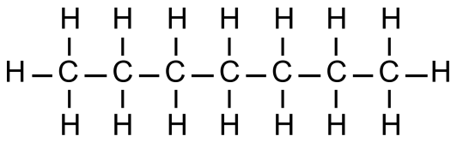a)

b)



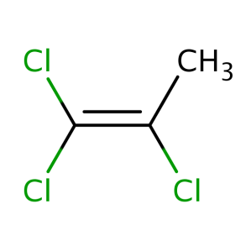c)

d)



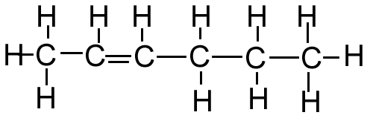e)

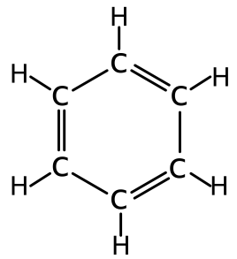

f)

i)



4. Draw the structure of the following compounds: **(7 marks)**

* 1. 2-methyl-3-ethyloctane
  2. *trans*-3-methylhex-3-ene

* 1. Methylpropane
  2. 1,1-dichloroethane
  3. *cis*-hex-3-ene
  4. 2-chloro-4-methyloctane
  5. ethylbenzene

5. Each of the following compounds has been **named incorrectly** according to IUPAC.

In each case **describe** the error(s) in naming, and write the correct name.

*(Hint: You will probably need to draw them)*  **(6 Marks)**

1. 1,3-diethylpent-1-ene

Description of error(s):

Correct IUPAC name:

1. 1,1-dichloro-2-bromobut-4-ene

Description of error(s):

Correct IUPAC name:

1. *trans*-1,1-difluoroethene

Description of error(s):

Correct IUPAC name:

**Extended Answer Calculations question** **(8 Marks)**

6. A portable gas stove that has become popular of late runs on aerosol-like cans of **butane**.

These stoves use a combustion reaction between the butane and oxygen gas drawn from the

surrounding air.

1. Construct a balanced chemical equation for the complete combustion of butane. (2 marks)
2. If, while boiling a kettle, 1.00 moles of butane were consumed, how many moles of Oxygen gas were required to be drawn from the air? (1 mark)
3. What is the Molar mass of butane? (1 mark)
4. During another cooking event, 150.0g of butane was burnt completely.
5. How many moles of butane is this? (1 mark)
6. What mass of oxygen is required to complete this reaction? (3 marks)